**A Novel Approach for Multipurpose web based test and evaluation**

**Dr.S.Mohan kumar**,

New Horizon College of Engineering, Research Centre,Bangalore,India.

# 1.Introduction

Today ,Online Examination System is considered a fast developing examination method because of its accuracy and speed. It is also needed less manpower to handle the examination. Almost all organizations today, are managing their exams by online examination system, since it reduces student's time in examinations. Organizations can also easily monitor the progress of the student that they give through an examination. As a result of this, the result is calculated in less time. It also helps diminishing the need for paper. Online examination project in PHP is very useful to learn it, According to today’s requirement Online examination system is significantly important to the educational institution to prepare the exams, saving the time and effort that is required to check the exam papers and to prepare the results reports. Online examination system helps the educational institutions to monitor their students and keep eyes on their progress. The best use of this system in Scholastic Institute and training centres because it helps in managing the exams and get the results in easy and an efficient manner. Until today the preparing for exams and preparing the results was performed manually, this required more time to complete.

**1.1 Purpose of Study**

The purpose of online test simulator is to take online test in an efficient manner and no time wasting for checking the paper. The main objective of online test simulator is to efficiently evaluate the candidate thoroughly through a fully

automated system that not only saves lot of time but also gives fast results.

For students they give papers according to their convenience and time and there is no need of using extra thing like paper, pen etc.

**1.2 Problem Statement**

Since the traditional have many drawbacks such as time consuming, Difficulty of analysing the test manually, More observers are required to take exam of many students, Results are not accurate since calculations is done manually, The chance of losing exam's result is higher in current systems, Checking of result is time consuming since it done manually, Limitation of no of student can give examination at a time. with the development of information technology and use it in an orderly and properly helps to overcome the existing error in the manual system . Online examination system saves the exams information in a database, and this make it an easier way to give exam teachers can add theirs exams rules , and student can give exam in a totally automated system

**1.3 Motivation**

* You never have to print an exam for your students and hand them out. Saves paper. Saves trees.
* It saves you money. You don't need to buy any paper.
* It saves time. It will auto-grade itself.

**1.4 Methodology**

* The proposed system takes the name of the candidates as input as they start the examination.
* The welcome screen will appear with the name of the candidate attempting the examination.
* After, Welcome screen the instruction will come there will be instructions instructing the candidate about the rules and regulations of the examination.
* Then the candidate should press start button to start the quiz .
* Once, the start button is pressed, 1st question will appear and the timer will start automatically.
* The candidate must complete the quiz in the given time.
* Quiz will end once all the question will be attempted by the candidate.
* After attempting all the question the candidate can press the finish button, and the result screen will be displayed.
* The result screen will show no. of correct answer and percentage.
* This system can be used by colleges for taking small test or quiz and can be used by companies for aptitude test.

# 2.System Requirements

2.1 Hardware and software requirements

Processor - Intel Core i5

Speed - 1.8 GHz

RAM - 256 MB (min)

Hard Disk - 10 GB

Operating System - Windows

Programming Language - Java

Compiler - Java Compiler

2.2 About the Language

• This is a Java project that is general-purpose computer-programming language that is concurrent, class-based, object oriented.

• This language is intended to let application developers ”write one, run anywhere”. That means compiled Java code can run on all platforms that supports Java without need of recompilation.

**3.System Design**

3.1 Architecture

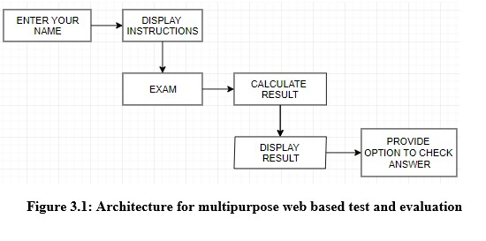

**3.2 Algorithm**

Step 1: Start.

Step 2: Enter your name.

Step 3:Read the instruction carefully.

Step 4: Tick the correct choice.

Step 5: Press finish result will be calculated.

Step 6: Show the result.

Step 7: Stop.

**3.3 Flow Chart**



**3.4 code**

/* online test with time limit */

import java.awt. *;

import java.awt. event.*;

import javax.swing.*;

class QuestionSeries{

static String info ="Java Online Test Week \n \nINSTRUCTIONS:\nThere are 25 questions in this test and 10 minutes to complete them all.\nThe finish button is highlighted in blue when you reach the end of the test. \nClicking the finish button will display the results with the correct answers marked in light red. \n \nThe timecounter begins when you click on the 'start' button \n \nBest of luck!\n";

static String []question ={"Question 1:\nWhat is the result of attempting to compile and run the following program?\n\npublic class JavaAppclass{\npublic static void main(String args){\n String myString = \"javaprograms\";\n System.out.println(myString);\n }\n}\n",

"Question 2:\nWhat is the result of attempting to compile and run the following program with \n\n>javac JavaApp.java\n>java JavaApp\n\nclass TryFirst{\n String myString = \"javatest\";\n}\n\nclass JavaApp{\n\npublic static void main(String[] arg){\n System.out.println(new TryFirst().myString);\n}\n}\n",

"Question 3: \nWhat is the result of attempting to compile and run the following program with \n>javac JavaApp.java\n>java JavaApp\n\nclass MyJavaApp{ \n String myString = \"elephants\"; \npublic static void main(String[] arg){ \n System.out.println(myString); \n } \n}\n",

"Question 4:\nWhat is the result?\n\nclass JavaApp{ \n public static void main(String[] a){ \n String textstr = \"hello\";\n for (int i=4; i<5; i++)\n System.out.println(str); \n } \n}\n",

"Question 5:\nWhat is the result here?\n\nclass MyJavaApp{ \n public static void main(String[] a){ \n int j=0;\n for (int i=0; i<3; i++) j=j+i;\n System.out.println(j); \n } \n}\n",

"Question 6:\nWhat is the result?\n\nclass MyJavaApp{ \n public static void main(String[] a){ \n int num1;\n int num2 = 7;\n num2= num1 * 2 +3;\n System.out.println(num2); \n } \n}\n",

"Question 7:\nWhat is the result?\n\nclass MyJavaApp{ \n int num1;\n public static void main(String[] a){ \n number1=2;\n int number2 = 7;\n number2= number1 * 2 +3;\n System.out.println(number2); \n } \n}\n",

"Question 8:\nWhat is the result?\n\nclass JavaApp{ \n static int number1 = 4;\n public static void main(String[] a){ \n number1=2;\n int number2 = 7;\n number2= number1 * 2 +3;\n System.out.println(number2); \n } \n}\n",

"Question 9:\nWhat is the result?\n\nclass JavaApp{ \n static int number1 = 3;\n public static void main(String[] arg)\n int number2 = 7;\n number2= number2 + number1 * 2 +3;\n System.out.println(number2); \n } \n}\n",

"Question 10:\nWhat is the result of compiling and running the following code?\n\nclass JavaApp{ \n public static void main(String[] a){\n int x = (int) (Math.random());\n System.out.println(x); \n } \n}\n",

"Question 11:\nWhat is the result?\n\nclass Tryclass{ \n static String text = \"rabbit\";\n public static void main(String[] a){\n int num = text.length;\n System.out.println(num); \n } \n}\n",

"Question 12:\nWhat would be the result here?\n\nclass Myclass{ \n public static void main(String[] a){\n char []rabbit={'a','b','c','d'};\n int num = rabbit.length;\n System.out.println(num); \n } \n}\n",

"Question 13:\nWhat is the result here?\n\nclass JavaApp{ \n public static void main(String[] a){\n int number = 10;\n String mystr = Integer.toBinaryString(number);\n System.out.println(mystr); \n } \n}\n",

"Question 14:\nWhat would be the result if we were to run this program with\n>java MyJavaApp hello java world ?\n\nclass MyJavaApp{ \npublic static void main(String[] args){\n System.out.println(args[1]); \n } \n}\n",

"Question 15:\nWhat is the result of this program?\n\nclass MyJavaApp{ \n public static void main(String[] a){\n double d =1.75;\n int i = d;\n System.out.println(i++); \n } \n}\n",

"Question 16:\nWhat is the result of this program?\n\nclass MyJavaApp{ \n public static void main(String[] a){\n int 1stNum = 5;\n int 2ndNum = 3;\n double d =1.25 +1stNum/2ndNum;\n System.out.println(d); \n } \n}\n",

"Question 17:\nWhat is the result of this program?\n\nclass MyJavaApp{ \n public static void main(String[] arg){\n int Num1 = 5;\n int Num2 = 4;\n double d =1.25 +Num1/Num2;\n System.out.println(d); \n } \n}\n",

"Question 18:\nWhat is the result of this program?\n\nclass TryJavaApp{ \n static float f;\n public static void main(String[] ar){\n int Number = 5;\n f = 1.25; \n System.out.println(f*4); \n } \n}\n",

"Question 19:\nWhat is the result of this program?\n\nclass JavaApp{ \n static float f;\n public static void main(String[] ar){\n int Num = 2;\n f = (float)1.25 * 2; \n System.out.println(f * Num); \n } \n}\n",

"Question 20:\nWhat is the result of this program?\n\nclass HelloJavaApp{ \n public static void main(String[] ar){\n byte num = 64;\n num += num;\n System.out.println(num); \n } \n}\n",

"Question 21:\nWhat is the result of this program?\n\nclass JavaApp{ \n public static void main(String[] a){\n double d = 1.56789;\n long num = Math.round(d);\n System.out.println(num); \n } \n}\n",

"Question 22:\nWhat is the result of this program?\n\nclass JavaApp{ \n public static void main(String[] a){\n double d = 1.56789;\n int num = (int)Math.round(d * d);\n System.out.println(num); \n } \n}\n",

# 4 .Results and Discussion

**4.1 Summary of result obtained**

Using an open source language gives us more flexibility, but at the same time it required more time to be programmed.The proposed Online Examination System (OES) can be easily adopted by universities and institutions in order to make the exam more secure and more flexible.The system is subdivided into two main subsystems (student and administrator) that are designed to give the system maximum benefit by demonstrating carefully each subsystem service.The administrator's functions are clearly identified to be able to manipulate user's information such as add (register), delete users and managing the exam materials and content such as add, delete questions, Thus the proposed system is easy and flexible because for future maintenance and development because each subsystem can be handled separately without influence on other system.

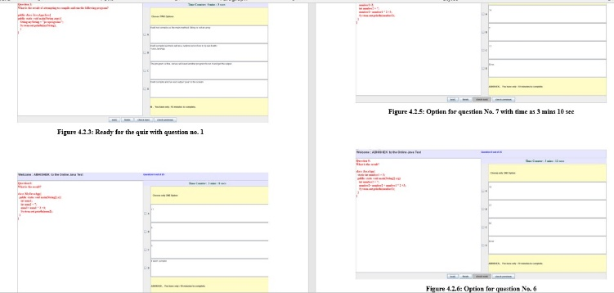

Fig 4.1 Expected Results

# 5.Conclusion

The Online test System is developed using Java and sql fully meets the objectives of the system for which it has been developed. The system has reached a steady state where all bugs have been eliminated. The system is operated at a high level of efficiency and all the teachers and user associated with the system understands its advantage. The system solves the problem. It was intended to solve as requirement specification

# 6.References

The following books and website were very helpful during the completion of project:

* SWeaver, D., et al. (2005). Evaluation: WebCT and the student experience. Evaluations and Assessment Conference.
* Tate, L. (2002). "Using the interactive whiteboard to increase student retention, attention, participation, interest, and success in a required general education college course." Retrieved January 30: 2007.
* Tallent-Runnels, M. K., et al. (2006). "Teaching courses online: A review of the research." Review of educational research 76(1): 93135.
* Downing, D., et al. (2000). Dictionary of computer and Internet terms, Barron's Educational series.
* http://googleweblight.com